1. *Unit sample signal*

http://www.cpp.edu/~zaliyazici/ece308/Matlab-ex_files/image002.gif

*Matlab code:*

n=-5:5;

x=[n==0];

stem (n,x)

http://www.cpp.edu/~zaliyazici/ece308/Matlab-ex_files/image006.gif

*Matlab code:*

n=-5:5;

x=[(n-2)==0];

stem (n,x)

1. *Unit step signal*

http://www.cpp.edu/~zaliyazici/ece308/Matlab-ex_files/image010.gif

*Matlab code:*

n=-5:5;

x=[n>=0];

stem (n,x)

http://www.cpp.edu/~zaliyazici/ece308/Matlab-ex_files/image014.gif

*Matlab code:*

n=-5:5;

x=[(n-2)>=0];

stem (n,x)

1. *Unit ramp signal*

http://www.cpp.edu/~zaliyazici/ece308/Matlab-ex_files/image018.gif

*Matlab code:*

n=-5:5;

x=n.*[n>=0];

stem (n,x)

http://www.cpp.edu/~zaliyazici/ece308/Matlab-ex_files/image022.gif

*Matlab code:*

n=-5:5;

x=(n-2).*[(n-2)>=0];

stem (n,x)

1. *Real valued exponential signal*

http://www.cpp.edu/~zaliyazici/ece308/Matlab-ex_files/image026.gif

*Matlab code:*

|  |
| --- |
| n=-20:20;  x=(0.9.^n).*[n>=0];  stem (n,x) |

http://www.cpp.edu/~zaliyazici/ece308/Matlab-ex_files/image030.gif

*Matlab code:*

|  |
| --- |
| n=-20:20;  x=(0.9.^(n-3)).*[(n-3)>=0];  stem (n,x) |

1. *Complex-valued exponential signal*

http://www.cpp.edu/~zaliyazici/ece308/Matlab-ex_files/image034.gif

*Matlab code:*

n=-5:40;

x=(exp((3*4j)*n)).*[n>=0];

y=real(x);

 subplot(2,1,1);

stem (n,y)

z=imag(x);

 subplot(2,1,2);

stem (n,z)

1. *Sinusoidal signal:*

http://www.cpp.edu/~zaliyazici/ece308/Matlab-ex_files/image038.gif

*Matlab code:*

n=-5:40;

x=4*cos(0.1*pi*n+pi/3);

stem(n,x)

http://www.cpp.edu/~zaliyazici/ece308/Matlab-ex_files/image042.gif

stem(n,x)

x=4*cos(0.1*pi*n+pi/3)+3*sin(0.3*pi*n+pi);

stem(n,x)

1. *Signal Addition:*

http://www.cpp.edu/~zaliyazici/ece308/Matlab-ex_files/image046.gif

n1 = 0:4;

x1 = [0 1 2 3 4];

n2 = -2:2;

x2 = [2 2 2 2 2];

n = min(min(n1),min(n2)):max(max(n1),max(n2)); % duration of y(n)

y1 = zeros(1,length(n)); y2 = y1;              % initialization

y1(find((n>=min(n1))&(n<=max(n1))==1))=x1;     % x1 with duration of y

y2(find((n>=min(n2))&(n<=max(n2))==1))=x2;     % x2 with duration of y

y = y1+y2;                                     % sequence addition                                     % addition

stem(n,y)

we can represent http://www.cpp.edu/~zaliyazici/ece308/Matlab-ex_files/image050.gif, and http://www.cpp.edu/~zaliyazici/ece308/Matlab-ex_files/image046.gif signals as follow.

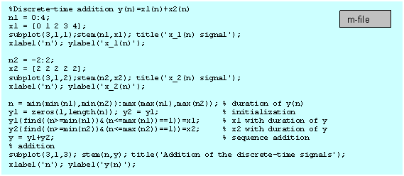

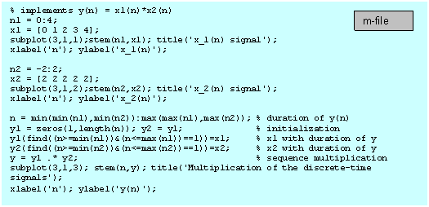

1. *Shifting a non-function discrete-time signal*

%Shifting a non-function Discrete-time signal

n = 0:8;

x = [0 1 5 2 1 3 6 4 5];

subplot(2,1,1);stem(n,x); title('x(n) signal');

xlabel('n'); ylabel('x(n)');

m=n+2; y=x;

subplot(2,1,2);stem(m,y); title('y(n)=x(n-2) signal');

xlabel('n'); ylabel('y(n)');

1. *Folding a Discrete-time signal*

